Museum Wharf: Site and Building 4 – As Is Diagrams

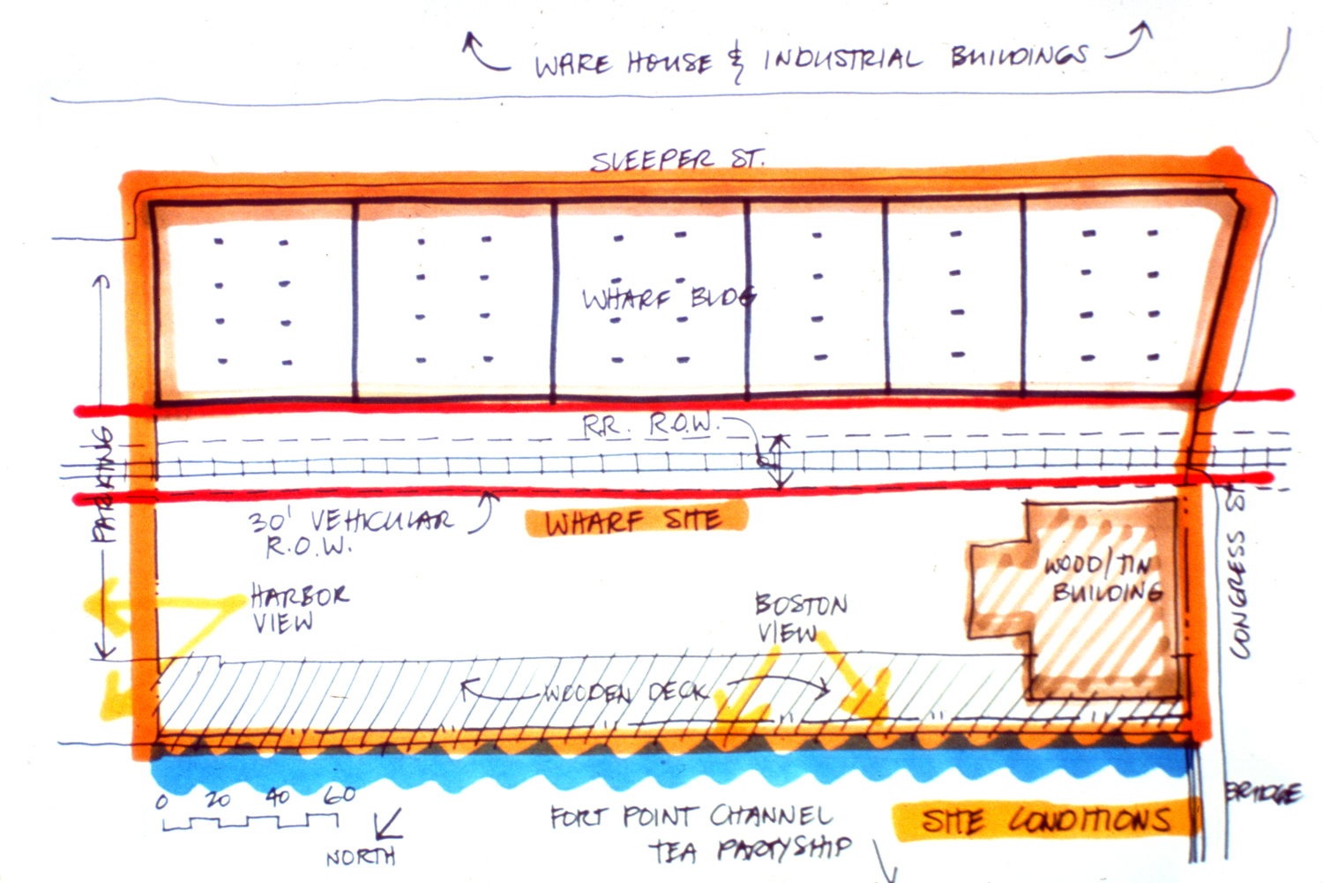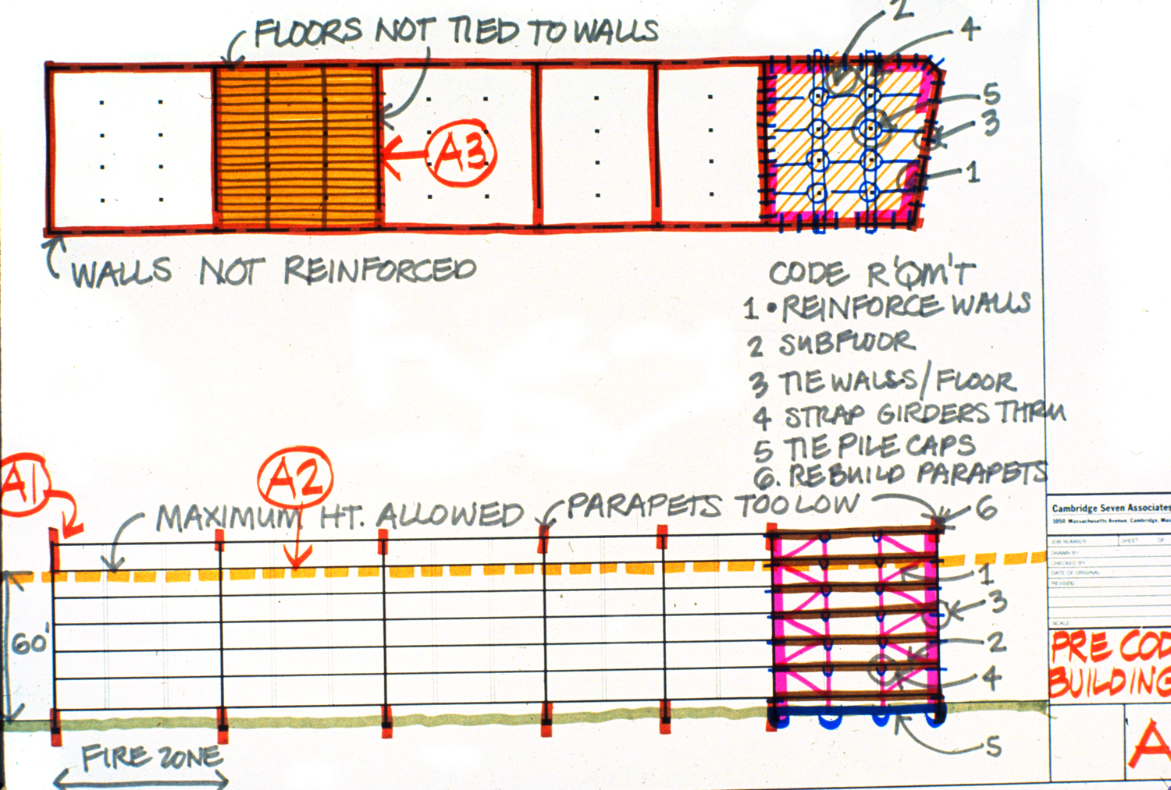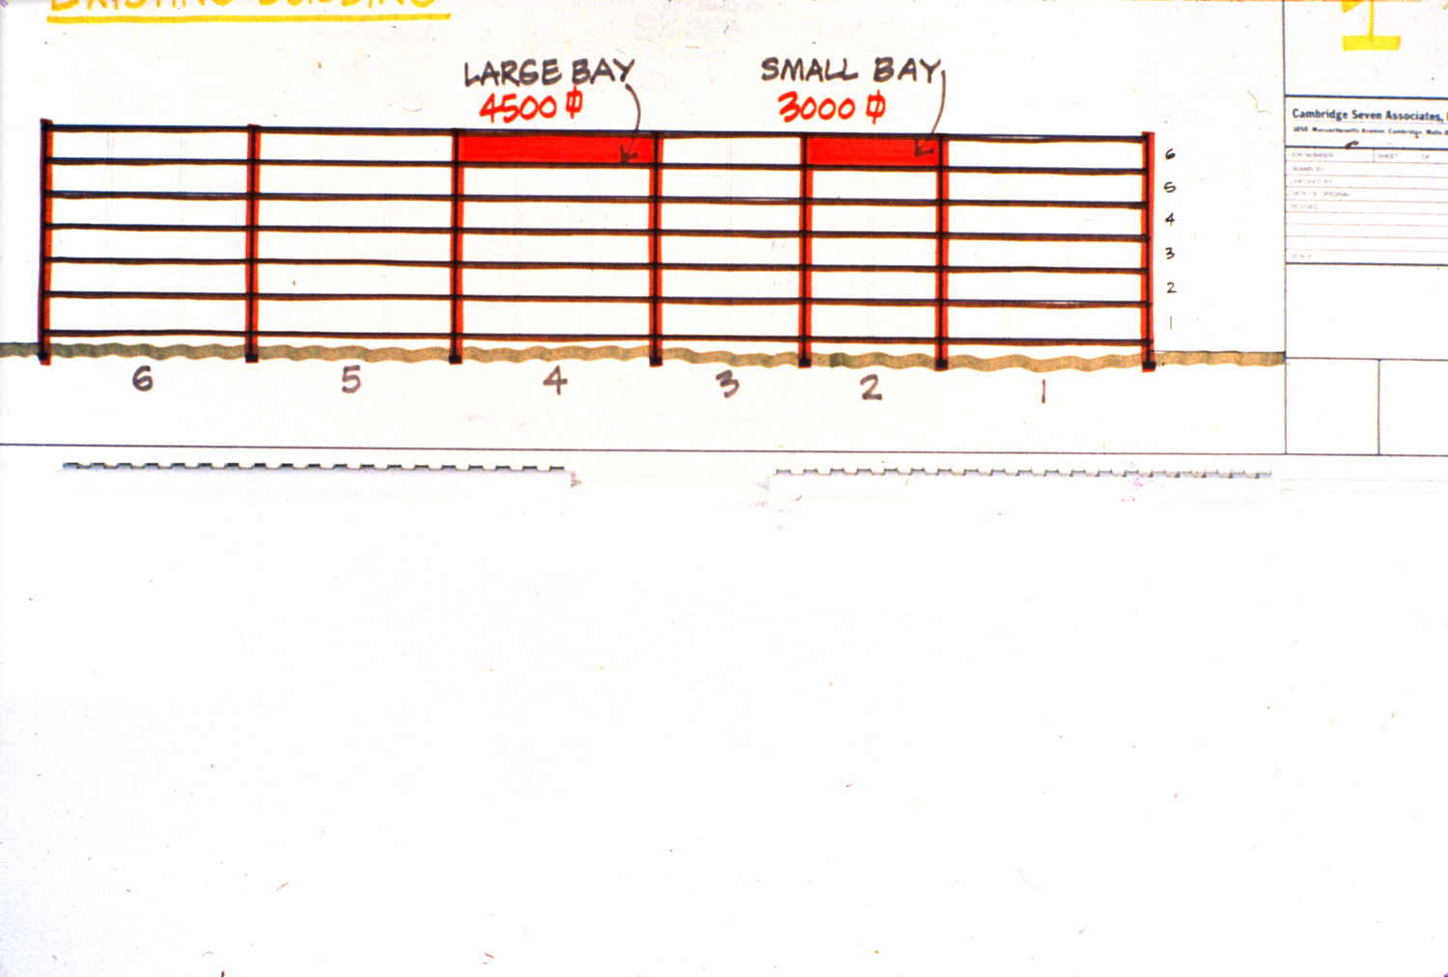
ms 0056.jpg ms 0057.jpg ms 0058.jpg

